Toyhouse@SUTD-IDC

**1. Introduction**

The curriculum provided by SUTD-IDC creates a wide range of choice for students from all disciplines, where cross-domain knowledge is available for everyone.

Toyhouse creates a learning ecology for students from different areas of study to meet together, generate ideas, and conduct research. XLP as a method to design learning process for students, creates a transdisciplinary learning environment in which students work as groups to experience a complete life cycle of product, system, or service design. From these short-term learning activities, they will obtain the facility to identifying and navigating sophisticated problems by utilizing all available resources, they will construct the awareness of collaborative learning, and start making long-term plans for their career.

Collaboration of Tsinghua-Toyhouse and SUTD-IDC will provide a more encouraging learning environment to support design research.

Specifically, these goals can be achieved by:

1. Co-design learning activities at Tsinghua and SUTD-IDC.
2. Exchange students between Tsinghua and SUTD-IDC.
3. Cooperation on Engineering Education Research.

**2. Co-design Learning Activities (XLP) at Tsinghua University and SUTD-IDC**

2.1 Summer Student Program 2013

Three workshops will be organized between July and September: International Summer Program (August 3 – August 10), XLP for Kids (August 8 – August 20), Lego2Nano (September 1 – September 8). The preparation phase starts from July. We invite **3+ students** from SUTD-IDC to come to Tsinghua University and design the proposed three activities with students at Toyhouse.

2.2 XLP Design Methodology

A learning activity can be efficiently designed by following a standard workflow. XLP uses a dual-stage design model, in which students design challenges for themselves. The Challengers prepare for the content, assignments and tasks prior to the course, the Missionaries take the challenge from the Challengers. In addition, course stuff provides guidelines, supportive resources to enable the process. This process can be illustrated by the following graph:

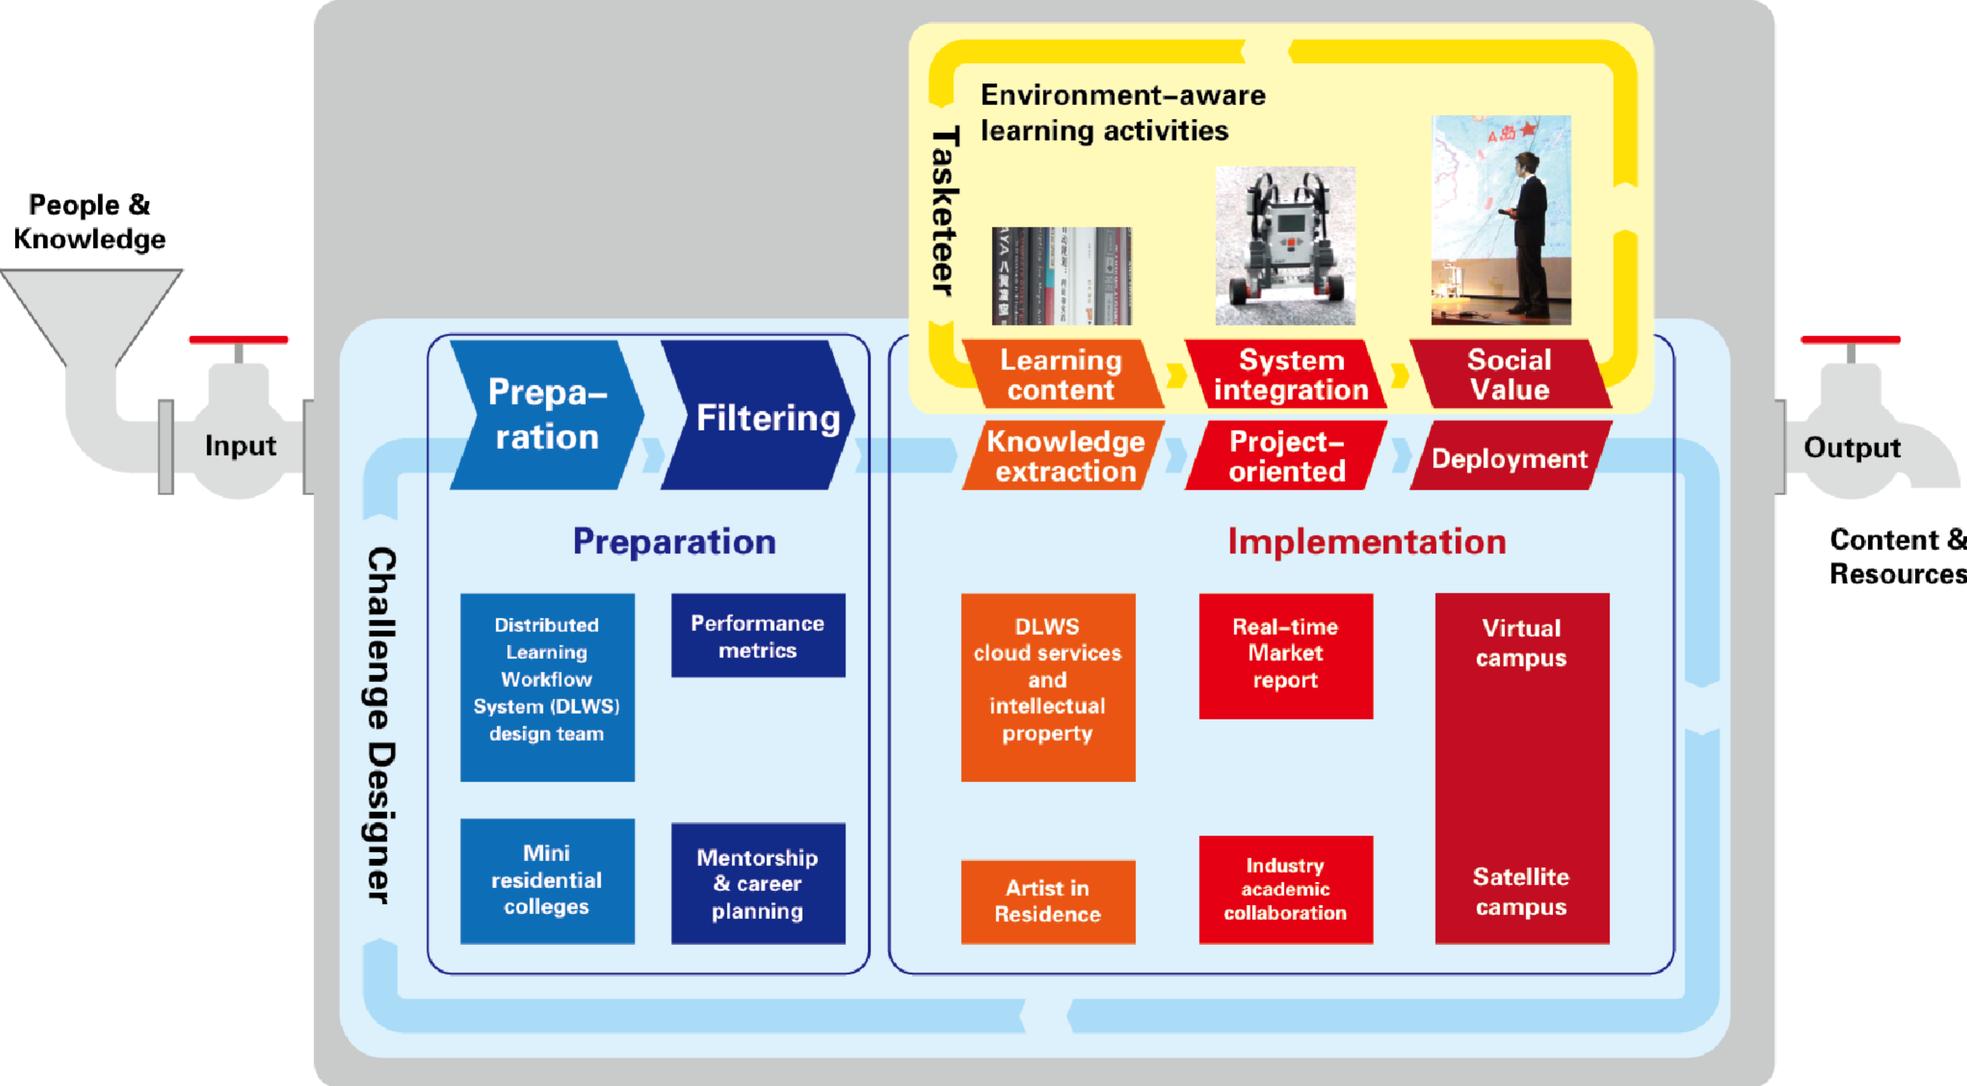

2.3 Future Course Content Design

With its flexibility, XLP can incorporate a variety of different content. It will be a good introduction to new students who will involve in the design projects in the future.

According to the most demanding needs, building a sustainable living environment is the challenge all countries face together, especially in the developing world. Based on the research at SUTD-IDC, the following aspects of research should be designed as elements in the learning activities:

1. Building Sustainable Architecture

As one of the major research areas at SUTD-IDC, designing and prototyping sustainable architecture is essential. In the course-design process, challengers will extract key ideas in architecture design and put them into the assignments to challenge other students.

1. Product and System Design

Engineering products are essential to create the building blocks of the sustainable environment. In this part, the challenge designers will involve themselves in the research projects at SUTD-IDC, and design components of the challenge based on what they learned from the research project, together with researchers.

1. Information Systems

All participants should be able to use IT technology Connect all virtual and physical components. Challengers will prepare for modules to help students easily get access to services on the web, open-source tools, and computation facilities such as Mathematica and Modeling tools.

**3. Exchange students between Toyhouse and SUTD-IDC**

Students from both universities can visit and work at the other. Tsinghua students can help SUTD-IDC design and organize learning activities, and bring workforce to research groups at SUTD-IDC. SUTD-IDC students will bring powerful design thinking to Tsinghua.

Li Qian: For summer, invite 3 or more people from SUTD, for future, do you ideas how we exchange students?

**4. Engineering Education Research**

5.1 Learning Activity Workflow Design

For professional and scalable learning activity design, more structural and detailed process design is required. Universities have to integrate all online and offline resources so that knowledge content can be delivered quickly and smoothly. To tackle this, universities should be designed as a highly networked organization, in which process is abstracted into a computable model.

Prof. Zhang Hong Yan’s research team from Beijing Jiaotong University has been designing a configurable and context-sensitive process model for general learning workflow in universities. XLP will be one instance of the model.

(Workflow Architecture Picture Here)

5.2 Knowledge Management

One focus of the research is to manage various types of content (including text, media, notes), and help student use and reuse outcome from others.

5.2.1 Social Network Based Knowledge Management System

Toyhouse is collaborating developers of UUcampus from Peking University to build the architecture of a knowledge management system for learning activities.

5.2.2 Shu Miao: Evaluation System Research Design

(a. Market Currency. b. Design proper evaluation for education so that students can be stimulated in such an environment)

5.2.3 Li Qian: Evaluation and Performance Design

(a. Performance Evaluation b. Question Design, etc.)

5.3 Evaluation System Establishment

Evaluation system usually determines students’ behavior and performance. Research on this has two aspects:

First, how to effectively increase the quality and efficiency of learning process?

(Process management such as Dynamic Project Control)

Second, how to design the evaluation system so that the potential of students can be best enabled?

(Value System Construction)

5.4 Infrastructure Management

Transdisciplinary learning environment requires a set of infrastructure that enables communication, collaboration, and all other needs above for physical and online learning. For example, social network based online learning platform, modules for future development, learning space and so on.